**Output:**

1. **Menu**

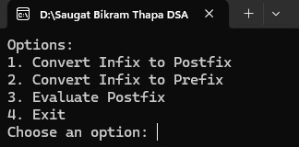

1. **Infix to Postfix**

1. **Infix to Prefix**

1. **Postfix Evaluation**

